Biography |  | 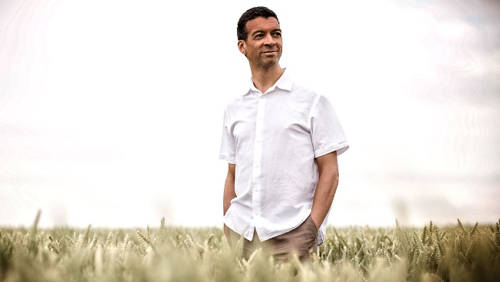

Roderick Williams OBE

Baritone
08.03.21

Roderick Williams is one of this country’s most sought after baritones and is constantly in demand on the concert platform and in recital, encompassing a repertoire from the baroque to world premieres. In 2016 he won the Royal Philharmonic Society’s Singer of the year award.

Opera engagements have included for Royal Opera House Covent Garden Schaunard/La bohème and Ned Keene/Peter Grimes; for English National Opera Papageno/Die Zauberflöte, Pollux in Rameau’s Castor and Pollux, and Jaufre Rudel in Saariaho’s L’amour de loin ,as well as world premieres of From Morning to Midnight by David Sawer and A Better Place by Martin Butler. For Opera North his roles have included the title role of Don Giovanni, The Count/Le nozze di Figaro, Guglielmo/Cosi fan tutte, Figaro/Il barbiere di Siviglia, Ned Keene and Goryanchikov/From the House of the Dead. For Scottish Opera roles have included Marcello/La bohème, Lord Byron in the world premiere of Sally Beamish’s Monster and Count/ Figaro. Other notable world premieres have included Alexander Knaifel’s Alice in Wonderland and Michel van der Aa’s After Life for Netherlands Opera, as well as the title role in Robert Saxton’s The Wandering Jew with the BBC Symphony , which has been released on NMC to considerable critical acclaim. He made his North American opera debut singing Figaro/Il barbiere di Siviglia for Florida Grand Opera.

Among Roderick Williams’ many performances of opera in concert are recent appearances with the BBC Symphony Orchestra in Tippett’s The Knot Garden (Barbican) and Birtwistle’s The Second Mrs Kong (Royal Festival Hall) and with the London Symphony Orchestra and Daniel Harding Billy Budd. He has also sung the role of Eddie in Mark-Anthony Turnage’s Greek for the BBC. He has taken major roles in conductor Richard Hickox’s semi-staged performances of opera, including Britten’s Gloriana (Aldeburgh, 2003), Walton’s Troilus and Cressida and most of the Vaughan Williams operas. Other concert performances include Henze, Strauss, Stravinsky and Wagner (Donner in Das Rheingold for ENO).

Roderick Williams has sung concert repertoire with all the BBC orchestras, and many other ensembles including the Royal Scottish National Orchestra, Bournemouth Symphony Orchestra, Deutsches Symphonie-Orchester Berlin, Russian National Orchestra, Academy of Ancient Music, The Sixteen, Le Concert Spirituel, and Bamberg Symphony Orchestra. Recent successes include Britten’s War Requiem and Pilgrim in Vaughan Williams’s The Pilgrim’s Progress (semi-staged) with the Philharmonia, Jesus in The Last Supper by Birtwistle with the London Sinfonietta in Milan and Turin, Elgar’s Dream of Gerontius in Toulouse, a European tour of Handel’s Messiah with RIAS Kammerchor, Tippett’s The Vision of St Augustine with the BBC National Orchestra of Wales at the 2005 BBC Proms, Henze’s Elegy for Young Lovers with the Orchestre Philharmonique de Radio France, the world premiere of Birtwistle’s The Ring Dance of the Nazarene with VARA Radio (repeated at the BBC Proms), performances of Lieder eines fahrenden Gesellen at La Scala, concerts with the Philharmonia Baroque Orchestra in San Francisco, Scottish Chamber Orchestra and a concert with Bach Collegium Japan at the Edinburgh Festival.

Recent and future operatic engagements include Oronte in Charpentier’s Medée, Toby Kramer in Van der Aa’s Sunken Garden and Sharpless / Madam Butterfly for English National Opera, the title role in Eugene Onegin for Garsington Opera, the title role in Billy Budd for Opera North, Van der Aa’s After Life at Melbourne State Theatre and at Opera de Lyon, Captain Balstrode / Peter Grimes in a concert performance with the Bergen Philharmonic Orchestra, Papageno and Ulisse / Il ritorno di Ulisse in Patria for the Royal Opera House, Toby Kramer for Dallas Opera, a concert performance of Ned Keene/Peter Grimes with Accademia Nazionale di Santa Cecilia in Rome, Van de Aa’s Upload for Netherlands Opera, Oper Koln and the Bregenz Festival, and Christus / St John Passion in staged performances with the Berlin Philharmonic Orchestra and the Orchestra of the Age of Enlightenment both under Sir Simon Rattle.

Recent and future concert engagements include performances with Royal Liverpool Philharmonic, Manchester Camerata, BBC National Orchestra of Wales, BBC Philharmonic, BBC Symphony, Royal Scottish National Orchestra, the Hallé, Britten Sinfonia, City of London Sinfonia, King’s College Cambridge, Goldsmiths Choral Union, Ex Cathedra, The Sixteen, The King’s Consort, New London Consort, London Philharmonic Orchestra, Le Concert Spirituel, Ensemble Orchestral de Paris, Berlin Philharmonic, Rias Kammerchor, Orquesta Sinfonica de Euskadi, Netherlands Radio Philharmonic, Iceland Symphony, Danish National Radio Symphony, San Francisco Symphony, Utah Symphony, Berlin Philharmonic Orchestra, Music of the Baroque Chicago, Bach Collegium Japan, Cappella Amsterdam, New York Philharmonic, Britten War Requiem with the Maggio Musicale and Semyon Bychkov in Florence, the UK premiere of Sally Beamish’s Judas Passion with the Orchestra of the Age of Enlightenment as well as with Philharmonia Baroque. In 2014 Roderick was the featured soloist at the BBC Last Night of the Proms.

He is an accomplished and highly sought after recital artist who can be heard regularly at venues and festivals including Kings Place, LSO St Luke’s, the Perth Concert Hall, the Concertgebouw, Oxford Lieder Festival, London Song Festival, Howard Assembly Room, the Musikverein, Vienna and on Radio 3, where he has participated on Iain Burnside’s Voices programme. Recent recitals include various performances at the Wigmore Hall including the three Schubert cycles, recitals for the BBC, the Concertgebouw and appearances at the Ludlow Song Festival, Oxford Lieder Festival, Three Choirs Festival and at the Bath International Music Festival.

His numerous recordings include Vaughan Williams, Berkeley and Britten operas for Chandos, and an extensive repertoire of English song with pianist Iain Burnside for Naxos. He is currently in the process of recording the three Schubert Cycles for Chandos as well as recordings of Stanford and Somervell for Somm.

He is also a composer and has had works premiered at the Wigmore and Barbican Halls, the Purcell Room and live on national radio. Recent commissions include a major work, World without End, for the Rias Kammerchor and BBC Singers as well as a commission to celebrate the centenary of the RAF. He was Artistic Director of Leeds Lieder + in April 2016 and he is currently 'singer-in-residence' for Music in the Round in Sheffield, presenting concerts and leading on dynamic and innovative learning and participation projects that introduce amateur singers, young and old, to performing classical song repertoire. He was awarded an OBE for services to music in June 2017.

Worldwide management:
Helen Hogh: hh@ grovesartists.com
Fiona Wells: fw@grovesartists.com
Please check with us if the document is more than two months old.

